Pushing after conflict resolution
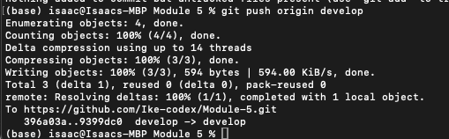
Check branch location
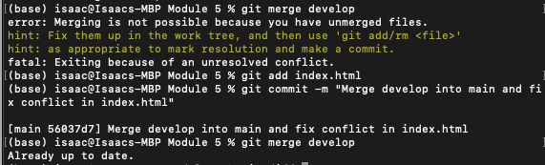
Review branch diff
